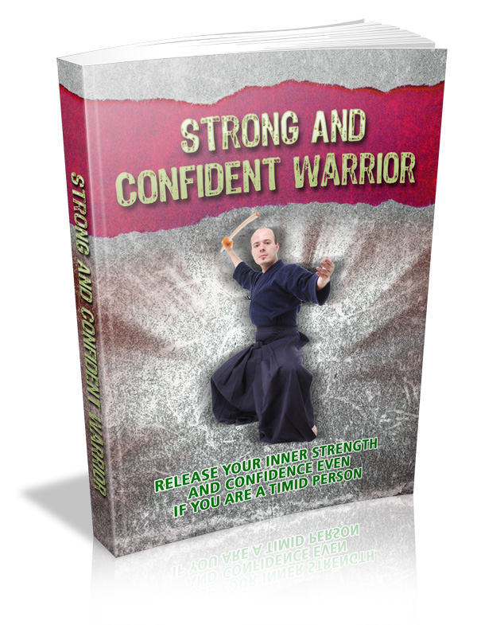

Terms and Conditions

LEGAL NOTICE

The Publisher has strived to be as accurate and complete as possible in the creation of this report, notwithstanding the fact that he does not warrant or represent at any time that the contents within are accurate due to the rapidly changing nature of the Internet.

While all attempts have been made to verify information provided in this publication, the Publisher assumes no responsibility for errors, omissions, or contrary interpretation of the subject matter herein. Any perceived slights of specific persons, peoples, or organizations are unintentional.

In practical advice books, like anything else in life, there are no guarantees of income made. Readers are cautioned to reply on their own judgment about their individual circumstances to act accordingly.

This book is not intended for use as a source of legal, business, accounting or financial advice. All readers are advised to seek services of competent professionals in legal, business, accounting and finance fields.

You are encouraged to print this book for easy reading.

Table Of Contents
Foreword

Chapter 1:
Why Better Yourself

Chapter 2:
Constructing Confidence

Chapter 3:
Motivation: The Heart Of Confidence

Chapter 4:
Unlocking Your Confidence

Chapter 5:
Crash Course To Confidence

Wrapping Up

Foreword

Everything that occurs… occurs for a reason. And occasionally, one thing leads to another. Rather than locking yourself away and weeping over preceding heartaches, embarrassment and failures, process them as your instructors and they'll become your tools in both self-improvement and success.

So, when does self-improvement turn into success? Where do we begin? Take these tips in this book.

Strong And Confident Warrior
Release Your Inner Strength And Confidence Even If You Are A Timid Person.

Chapter 1:
Why Better Yourself

Synopsis

Occasionally, when all our questions, dreads and insecurities wrap us up, we come up with the thought of “I wish I was someone else.”

More frequently than not, we think and trust that somebody or rather, most individuals are better than us - when actually, the fact is, many individuals are more frightened than us.


Why It Helps

You spot a completely attention-getting girl sitting by herself at a party, nonchalantly sipping on a glass of wine. You think to yourself, “She appears so utterly calm and confident.” However if you could read her mind, you'd see a bunch of scared thoughts and you may just be astonished that she’s thinking “are people discussing why I'm seated here alone?... Why don’t men find me attractive? …I don’t like my body, I look fat… I wish I was as smart as my best friend.”

We see a young business entrepreneur and state “what else could he need?” He stares at himself at the mirror and grumbles to himself, “I detest my eyes… I wonder why my friends won’t talk to me….”

Isn’t it curious? We look at others, envy them for looking so atrociously perfect and wish we could trade places with them, while they consider us and think of the same thing. We're envious of others who themselves are envious of us. We suffer from low self-regard, lack of assurance and lose hope in self-improvement as we’re enveloped in hushed desperation.

Occasionally, you may have an irritating habit like biting your nails or having a foul mouth, and you - of all individuals, is the last to know.

I've an acquaintance that never gets sick of talking. And in most conversations, she's the only one who appears to be interested in the things she has to say. So all of our other acquaintances tend to avoid her, and she doesn’t notice how socially hindered she is.
One key to self-reformation is to listen and speak to a trusted friend. Find somebody who you find easy to opening up to even with the hardest topics you wish to discuss. Ask questions like “do you believe I'm ill-mannered?”, “Do I forever sound argumentative?”, “Do I speak too loud?”, “Does my breath stink?”, “Do I ever bore you while were together?”

In that way, the other individual will obviously know that you're interested in the procedure of self-improvement. Listen to comments and criticisms and don’t add in things like “Don’t exaggerate! That’s simply the way I am!” Open your mind and heart too. And in return, you might wish to help your friend with constructive critique that will likewise help her improve her self.

One of Whitney Houston’s songs states “Learning to love yourself is the greatest love of all.” True! In order to love other people, you have to love yourself as well. Remember, you can't give what you don't have.

Before telling others some ways on to better themselves, let them see that you are a product of self-improvement. Self-improvement makes us better individuals, we then inspire others.

Quit thinking of yourself as a second-rate being. Forget the insistent thought of “If only I was richer… if only I was leaner” and so forth. Accepting your true self is the opening move to self-improvement. We have to stop comparing ourselves to other people only to discover at the end that we’ve got 5 more reasons to envy them.

We all bear our insecurities. Nobody is perfect. We forever wish we had better things, better features, better body parts, and so forth. But life need not to be perfect for individuals to be happy about themselves.

Self-improvement and loving yourself isn't a matter of crying out to the whole world that you're perfect and you're the best. It’s the virtue of acceptance and contentment. Once we start to better ourselves, we then start to feel content and happy.


Chapter 2:
Constructing Confidence

Synopsis

So how do you remain calm, composed and maintain confidence in tough surroundings? Here are a few tips you might to consider as a newbie guide to self-improvement.



Building It

Envisage yourself as a dartboard. Everything and everybody else around you might become darts, at one point or another. These darts will demolish your confidence and pull you down in ways you won’t even recall. Don’t let them demolish you, or get the best of you. So which darts ought you avoid?

Dart 1: Damaging Work Environment

Mind the “dog eat dog” theory where everybody else is fighting simply to get ahead. This is where non-appreciative individuals commonly thrive. No one will value your contributions even if you miss lunch and dinner, and sit up late. Most of the time you must work too much without getting help from anyone else. Stay out of this; it will destroy your self-esteem. Competition is at stake anyplace. Be healthy enough to compete, but in a levelheaded competition that is.

Dart 2: Other’s Action

Bulldozers, brown nosers, gossips, whiners, backstabbers, snipers, the walking wounded, controllers, naggers, bellyachers, exploders, patronizers, sluffers… all these sorts of individuals will pose bad vibes for your self-esteem, as well as to your confidence strategy.

Dart3: Altering Surroundings

You can’t be a greenish bug in a brown field. Alterations challenge our confidence. It tests our flexibility, adaptability and changes the way we think. Alterations will make life hard for awhile, it might cause stress but it will help us discover ways to better our selves. Change will always be around; we must be adaptable to it.

Dart 4: Preceding Experience

It’s all right to cry and say “ouch!” when we have pain. But don’t let pain transform itself into fear. It may grab you by the tail and swing you around. Treat every failure and error as a lesson.

Dart 5: Damaging World View

Consider what you’re looking at. Don’t envelop yourself with all the negativities of the world. In building confidence, we have to learn how to make the best out of riskiest situations.

Dart 6: Purpose

The way you are and your behavioral traits is said to be a mixed end product of your genetic traits , your raising , and your environmental surroundings like your spouse, the company, the economy or your circle of acquaintances. You have your own individuality. If your father is a loser, it doesn’t mean you have to be a loser too. Learn from others experience, so you’ll never have to meet the same errors.

Occasionally, you might wish to wonder if some individuals are born leaders or positive thinkers. NO. Becoming positive, and staying positive is a choice. Building self-assurance and drawing lines for confidence is a choice, not a rule or a talent. God wouldn’t descend from heaven and tell you - “Tom, you might now have the permission to build confidence and better your self.”

In life, it’s difficult to remain tough especially when matters and people around you keep pulling you down. When we get to the battleground, we ought to choose the right weapons and armor to use, and pick those that are unassailable. Life’s options provide us more options. Along the struggle, we'll get hit and bruised. And wearing an unassailable armor ideally means ‘self change’. The sort of change comes from inside.

Constructing confidence will eventually lead to self-improvement if we begin to become responsible for who we are, what we have and what we accomplish. It’s like a flame that ought to gradually spread like a brush fire from inside and out. When we grow self-esteem, we take charge of our mission, values and discipline. Confidence brings about self-improvement, true assessment, and determination. So how do you begin setting up the building blocks of self-esteem? Be positive. Be content and happy. Be appreciative. Never miss a chance to compliment. A positive way of living will help you establish self-esteem.

Chapter 3:
Motivation: The Heart Of Confidence

Synopsis

Pain might occasionally be the reason why individuals change. Getting failed grades make us recognize that we have to study. Debt prompts us of our inability to have better income. Being embarrassed gives us the ‘push’ to speak up and fight for ourselves to save face from the next embarrassments.

It might be a biting experience, a friend’s tragic story, an excellent movie, or a motivating book that will help us get up and get just the correct amount of motivation we require in order to better ourselves.


Get Inspired

With the infinite negativities the world produces, how do we preserve motivation? Try out the tips I organized!

Attain your dreams. Avoid damaging people, matters and places. Eleanor Roosevelt once stated the future belongs to those who trust in the beauty of their ambitions. Trust in your self, and in what you are able to accomplish.

Think about things on every angle and aspect. Motivation issues forth from determination. To be able to comprehend life, you ought to feel the sun from both sides.

Don’t give in and don’t quit. Edison failed once, twice, more than thrice prior to coming up with his invention the light bulb. Make motivation as your steering wheel.

Savor. Work as though you don’t need income. Dance as though nobody’s looking. Love as though you never cried. Learn as though you’ll live forever. Motivation comes about when individuals are happy.

Loved ones and acquaintances - are life’s greatest treasures. Don’t loose sight of them. Give more than what is adequate. Where does motivation and confidence take place at work? At home? At school? When you exercise extra effort in executing things.

Hold on to your aspirations. They might dangle in there for a minute, but these little stars will be your drive.

Brush off those who try to demolish you. Don’t let others get the best of you. Remain away from toxic individuals - the sort of people who detest hearing about your success.

Be yourself. The key to success is to be yourself. And the key to failure is to attempt to please everybody. Love your self. Now isn’t that simple?

Continue trying regardless how difficult life might seem. When an individual is motivated, eventually he sees a harsh life at last clearing out, paving the way to confidence.

Make things occur. Motivation is when your aspirations are put to work. Practice makes perfect. Practice is about motivation. It lets us learn ways to recover from our errors.

Never lie, swindle or steal. Always play fair.

Open up your eyes. Individuals ought to learn horse sense. They discover things in 2 ways - how they wish things to be, and how they ought to be.

Quitters never win. And winners never quit. So, pick your fate - are you going to be a quitter? Or a winner?

Motivation is likewise about preparation. We have to hear the little voice inside us telling us to get moving before other people will get on their feet and join in. Remember, it wasn’t raining when Noah constructed the ark. Quit procrastinating!

Take charge of your life. Discipline or willpower jives synonymously with motivation. Both are central factors in confidence.

Understand other people. If you know how to talk, you ought to also learn how to listen. Long to understand 1st, and to be understood 2nd.

Envision it. Motivation without imagination is like a boat on the ground. Want it more than anything. Dreaming means trusting. And to trust is something that's rooted in motivation and confidence.

Be different from the others. When you're motivated, you tend to apply “extras” in your life like extra time for family, extra help at work, extra care for friends, etc.

You're unique. No one in this world looks, behaves, or talks like you. Value your life and existence, as you’re just going to get one.

Home in on your dreams and go for it!

This preview copy ends here and to get the full product, please go to (the website URL ) here to get the full product.

